**LAB # 01**



**CSE102L Computer Programming Lab**

Submitted by: **Maaz Habib**

Registration No. :**PWCSE1952**

Class Section:**C**

“On my honor, as student of University of Engineering and Technology, I have neither given nor received unauthorized assistance on this academic work.”

Submitted to:

**Engr. Abdullah Hamid**

Month Day, Year (04,26,2021)

Department of Computer Systems Engineering

University of Engineering and Technology, Peshawar

**Lab 1: Introduction to C++**

**Objectives**

* To be able to install and use Dev C++ IDE for compiling C++ programs
* To be familiar with syntax and structure of C++ programming

**What is Dev C++ IDE:**

Dev-C++, developed by [Bloodshed Software](http://www.bloodshed.net/), is a fully featured graphical IDE (Integrated Development Environment), which is able to create Windows or console-based C/C++ programs using the MinGW compiler system. MinGW (Minimalist GNU* for Windows) uses GCC (the GNU g++ compiler collection), which is essentially the same compiler system that is in Cygwin (the unix environment program for Windows) and most versions of Linux.

**How to compile C++ program:**

Click on File->New->Source File option.

1. Write your C++ program as shown below and save it ( ctrl+s ).
2. Once you have written the program, click on compile and run.
3. An output window will appear showing the result that is, Hello World printed.
4. Now, you are ready to go for the next chapter.

* **To be familiar with syntax and structure of C++ programming**

**Syntax of c++ programming:**

The term “Syntax” is a set of pre-defined protocols or rules that we need to follow in a programming language. Every programming language has its own unique syntax. Similarly, C++ Syntax also has its significance.

**Structure of C++ programming:**

Structure is a collection of variables of different data types under a single name. ... It is similar to a class in that, both holds a collection of data of different data types. For example: You want to store some information about a person: his/her name, citizenship number and salary.

**Lab Tasks**

**Task No 1**

**Write a program to display your name on console.**

In this program I have entered the name by programmer side.

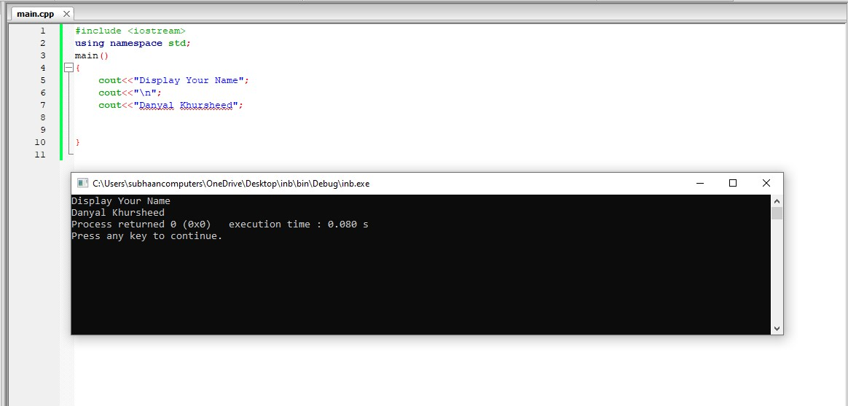

**Task No 2**

**Write a program to add two numbers (6+3=) and display its sum.**

In this program I have take two numbers from user and and added both the numbers.

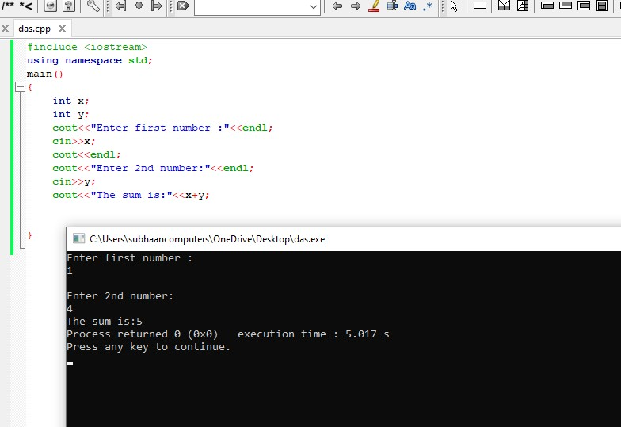

**Task No 3**

**Write a program to multiply three numbers (5x5x5=) and display its product.**

In this program I have 3 integers from user side and multiply with each other.

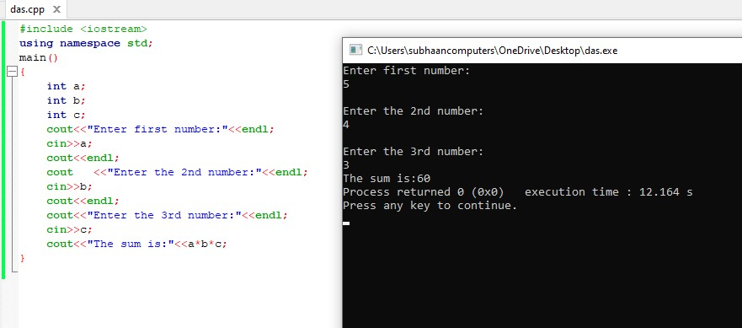

**Task No 4**

**Write a program to find the mod of (5%5=) and (5%6=).**

In this program I have called 4 integers (a,b,c,d) and find the mod of a and b and then find again the mod of c and d.

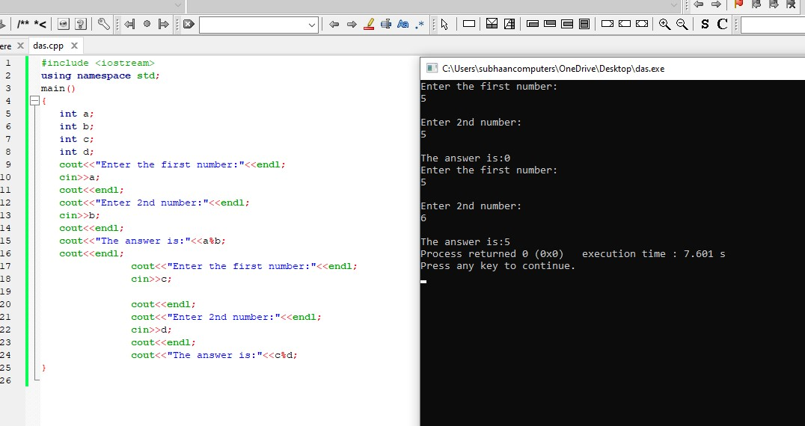

**Task No 5**

**Write a program to calculate area of a circle having its radius (r = 5).**

In this program we have called pi by float and r by integer . Then we have take the spure of r and multiply by pi.

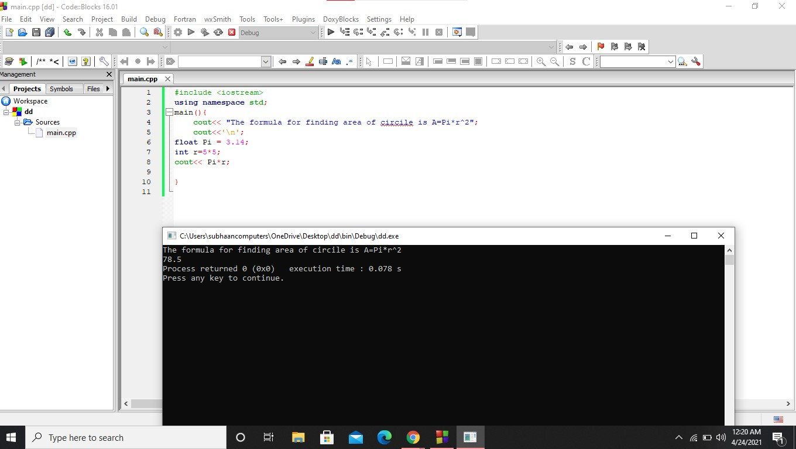

**Task No 6**

**Write a program to calculate area of an ellipse having its axes (minor=4cm, major=6cm)**

